**SPAM REVIEW DETECTION USING LINGUSTIC & BEHAVIORAL METHOD**

**SOFTWARE REQUIREMENT SPECIFICATION**

**INTRODUCTION**

The requirements are grouped by their stakeholders, and functional and non-functional requirements are separated.

**STAKEHOLDERS**

|  |  |
| --- | --- |
| U | User |
| A | Admin |

**Functional Requirements of User**

|  |  |
| --- | --- |
| R1 | The system must enable user to register themselves by providing their personal details. |
| R2 | The system must allow users to login through their username and password after registering. |
| R3 | The system must allow users to reset their profile. |
| R4 | The system must provide the spam score to the user |
| R5 | The system must show whether the review is spam or not |

**Functional Requirements of Admin**

|  |  |
| --- | --- |
| R6 | The system must allow Admin to login with valid credentials. |
| R7 | The System must allow Admin to access the database of the application. |
| R8 | The system must allow Admin to add/remove/block users profile. |
| R9 | The system must provide admin all control over credentials details of users. |

**Non-Functional Requirements**

|  |  |
| --- | --- |
| R10 | **Usability**  The system is designed with completely automated process hence there is no or less user intervention. |
| R11 | **Reliability**  The system is more reliable because of the qualities that are inherited from the chosen platform java. The code built by using java is more reliable. |
| R12 | **Performance**  This system is developing in the high level languages and using the advanced front-end and back-end technologies it will give response to the end user on client system with in very less time. |
| R13 | **Supportability**  The system is designed to be the cross platform supportable. The system is supported on a wide range of hardware and any software platform, which is having JVM, built into the system. |
| R14 | **Security**  The System shall provide security to user’s data. |

**USE CASE DIAGRAM**

**Description:** This diagram describes the actions performed by the actors .The user gives the input review and get the spam result and spam score(as pie chart).

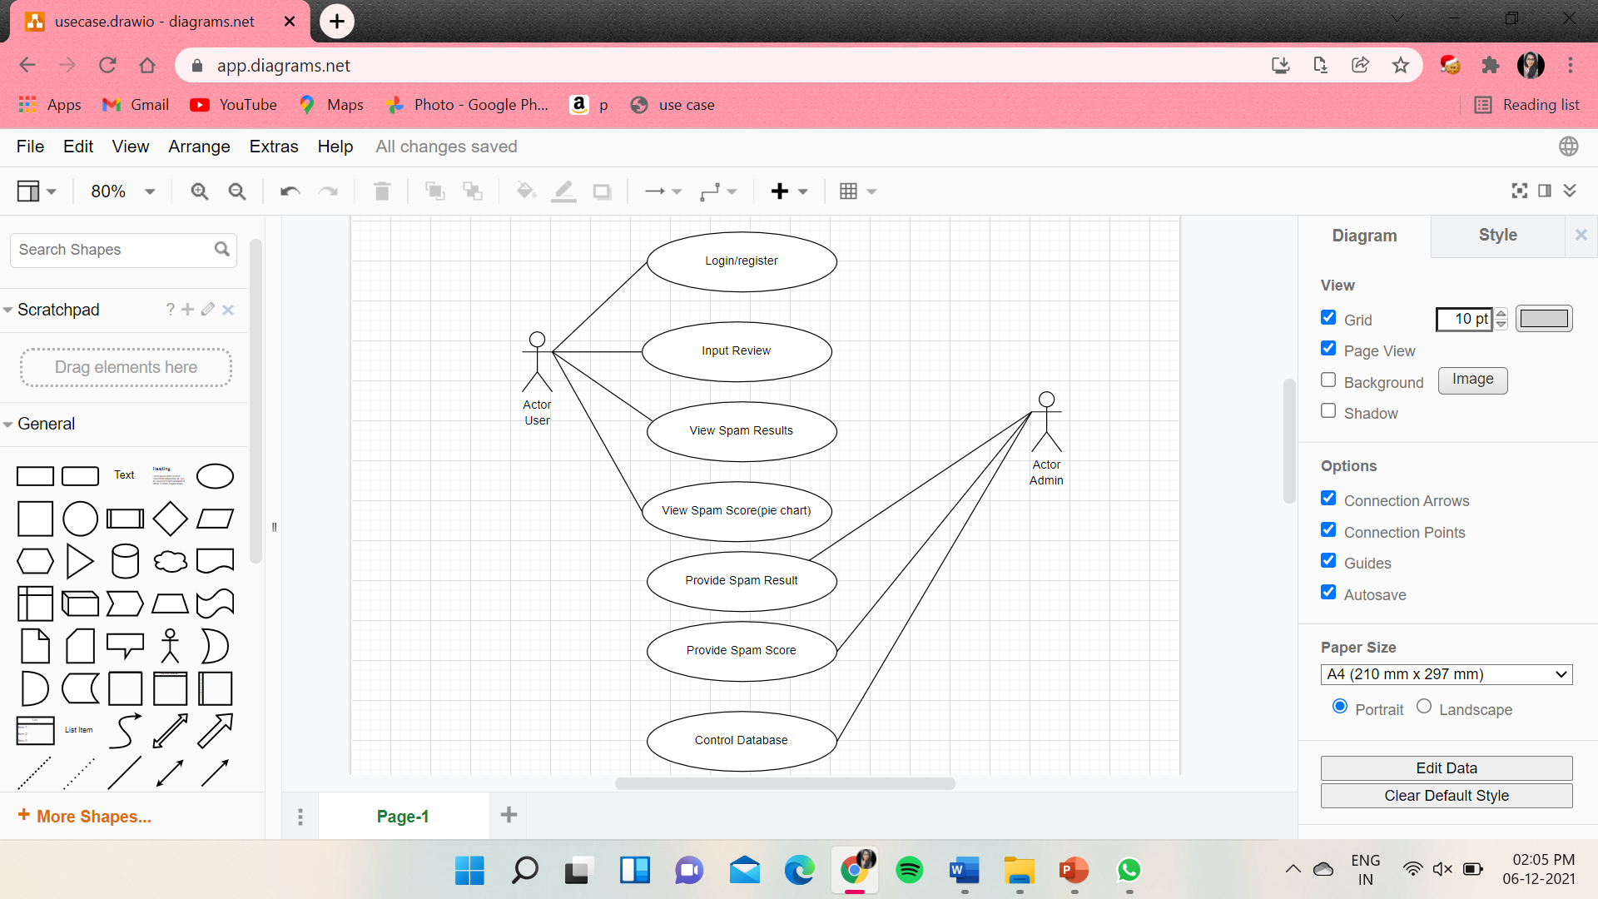

1. **LOGIN/REGISTER**

USER

Login/Register

**Initial Step-By-Step Description**

Before, this use case is initiated, the user has already access to internet and opened the website

1. The user clicks on Login button.
2. The user enters the username in the space provided.
3. The user enters the respective password.
4. If the user forgets his/her password, they click on forgot password option.
5. The user clicks on submit button to login successfully.

|  |  |
| --- | --- |
| **Use Case Name** | Login/Register |
| **XRef** |  |
| **Trigger** | The User enters the credentials to login/register |
| **Precondition** | The User should initially have access to the website |
| **Basic Path** | User login through the website by providing his/her credentials. |
| **Alternative Paths** | The user should create an account if doesn’t exists |
| **Postcondition** | The User is directed to the input grid window |
| **Exception Paths** | The User may abandon the operation at any time. |
| **Other** |  |

2. INPUT REVIEW

USER

Input Review

**Initial Step-By-Step Description**

Before this use case is initiated the user is already login to the website.

1. The user sees the space provided to write the review.
2. The user enters his/her review in the input grid.
3. The user clicks on predict button.

|  |  |
| --- | --- |
| **Use Case Name** | Input Review |
| **XRef** |  |
| **Trigger** | The user should provide the review and click submit button |
| **Precondition** | The user should login with correct credentials and have access to the online website |
| **Basic Path** | User enter the correct credentials and write the input review in the grid |
| **Alternative Paths** |  |
| **Postcondition** | The system displays the review is spam or not and user can also get the spam score by clicking the spam score button. |
| **Exception Paths** | The User may abandon the operation at any time. |
| **Other** |  |

1. VIEW SPAM RESULT

USER

View SpamResult

**Initial Step-By-Step Description**

Before this use case in initiated the user is already provided the review in the input grid.

1. The user can view the result of the provided review.
2. The user understands if the provided review is spam or non-spam review.

|  |  |
| --- | --- |
| **Use Case Name** | View Spam Result |
| **XRef** |  |
| **Trigger** | Submitting the input review by the user in the provided input grid |
| **Precondition** | The user initially should give the review in the input grid |
| **Basic Path** | After submitting the system displays the spam result |
| **Alternative Paths** | The user can also get the spam score of the provided input review |
| **Postcondition** | The user can be redirected to the input grid window or can view the spam score. |
| **Exception Paths** | The attempt may be abandoned at any time. |
| **Other** | None |

1. VIEW SPAM SCORE

USER

View Spam Score

**Initial Step-By-Step Description**

Before this use case in initiated the user is already provided the review in the input grid.

1. The user clicks on view spam score button.
2. Pie-chart is displayed, which indicates the percentage of spam the review is.
3. User can logout of the website.

|  |  |
| --- | --- |
| **Use Case Name** | View Spam Score |
| **XRef** |  |
| **Trigger** | The user should click the spam score button |
| **Precondition** | The user should provide the input review |
| **Basic Path** | The user gets to view the pie-chart after submitting |
| **Alternative Paths** |  |
| **Postcondition** | User can get the spam score, later redirected to the input grid page or user may logout. |
| **Exception Paths** | The attempt may be abandoned at any time. |
| **Other** | None |